Views are virtual tables which fetch data from Base tables

Views could be

1. Simple View > which are based on single table , we can perform Insert , delete , update on simple views
2. Complex View > which are based on more than 1 table , we can perform Insert , delete , can not run update query on complex views

Create view HrView

As

Select * from employee where dept =’HR’

**Modify View**

Alter view HrView

As

Select id, name , salary from employee where dept =’HR’

**Drop View**

Drop view HrView

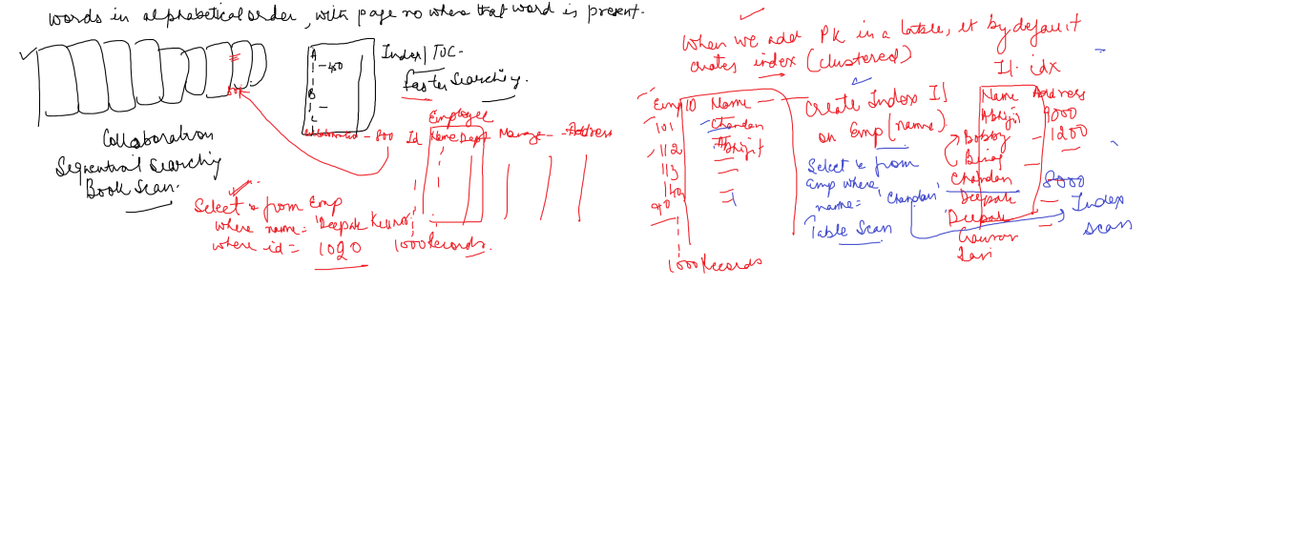

Index is used for faster searching of records

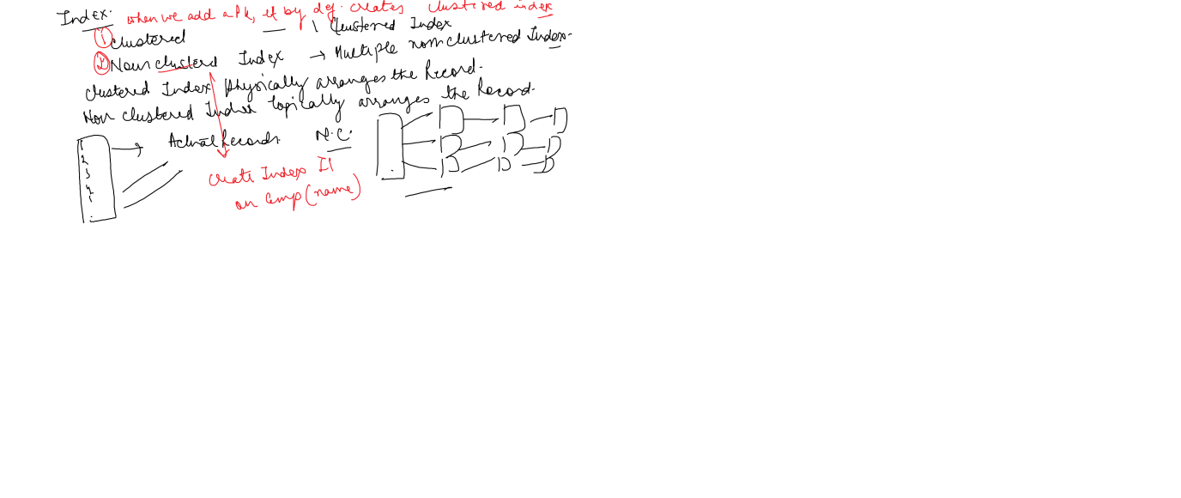

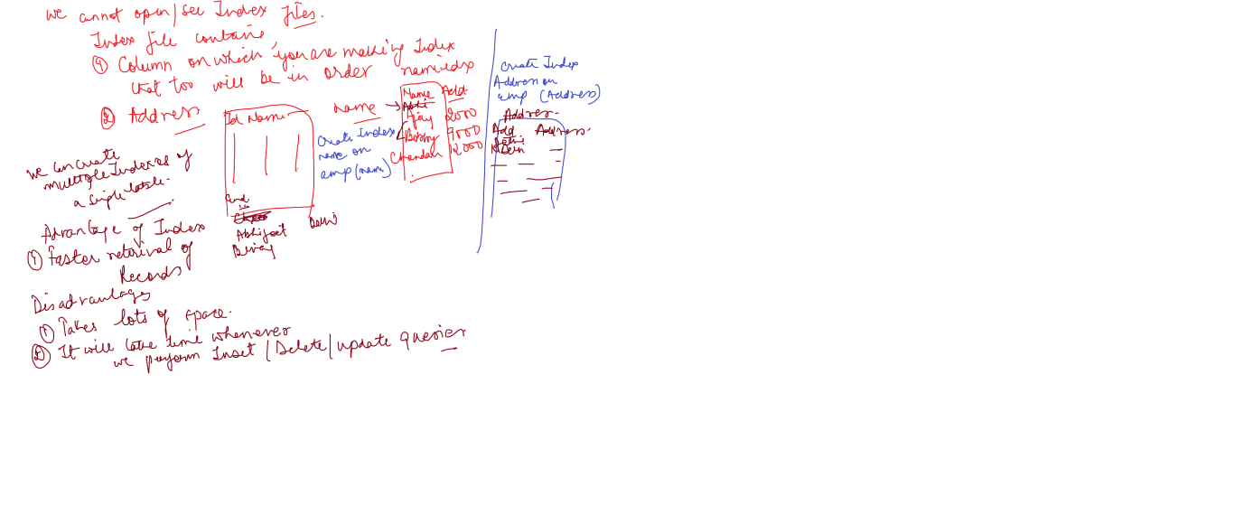

<https://www.c-sharpcorner.com/UploadFile/8af593/index-in-sql-server/>

Triggers : are sp stored procedure which are automatically called.

DML Triggers : When you perform Insertion Updation Deletion on tables

DDL Triggers : When you perform some action on database

DML Triggers

After/For

Instead of

create trigger T2

on emp

after insert

As

Begin

print 'Record inserted'

End

select * from emp

insert into emp values (6,'Ajay',9000)

create trigger T3

on emp

after delete

As

Begin

rollback

print 'Record can not be deleted'

End

delete emp

create trigger T2

on emp

after insert

As

Begin

print 'Record inserted'

End

select * from emp

insert into emp values (6,'Ajay',9000)

create trigger T3

on emp

after delete

As

Begin

rollback

print 'Record can not be deleted'

End

Exec sp_settriggerorder T4, FIRST, 'UPDATE'

exec sp_settriggerorder tr_au_upd, FIRST, 'DELETE'

delete emp

select * from emp

create trigger T4

on emp

for insert,delete,update

As

Begin

rollback

print 'Record can not be added or deleted or modified'

End

delete emp

select * from sys.triggers

CREATE TRIGGER tr_au_upd ON EMp

AFTER UPDATE,INSERT,DELETE

AS

PRINT 'TRIGGER OUTPUT' + CONVERT(VARCHAR(5),@@ROWCOUNT)

+ 'ROW UPDATED'

GO

delete emp